|  |  |
| --- | --- |
| TEAM ID | PND2022TMID30503 |
| PROJECT TITLE | CLASSIFICATION OF ARRYTHMIA BY USING DEEP LEARNING 2-D ECG SPECTRAL IMAGE REPRESENTATION |

# Apply ImageDataGenerator functionality to the trainset and testset:

We will apply ImageDataGenerator functionality to Trainset and Testset by using the following code.

This function will return batches of images from the subdirectories Left Bundle Branch Block, Normal, Premature Atrial Contraction, Premature Ventricular Contractions, Right Bundle Branch Block and Ventricular Fibrillation, together with

labels 0 to 5

{'Left Bundle Branch Block': 0, 'Normal': 1, 'Premature Atrial Contraction': 2, 'Premature Ventricular Contractions': 3, 'Right Bundle Branch Block': 4, 'Ventricular Fibrillation': 5}

We can see that for training there are 15341 images belonging to 6 classes and for testing there are 6825 images belonging to 6 classes.

This function will return batches of images from the subdirectories Left Bundle Branch Block, Normal, Premature Atrial Contraction, Premature Ventricular Contractions, Right Bundle Branch Block and Ventricular Fibrillation, together with labels 0 to 5{'Left Bundle Branch Block': 0, 'Normal': 1, 'Premature Atrial Contraction': 2, 'Premature Ventricular Contractions': 3, 'Right Bundle Branch Block': 4, 'Ventricular Fibrillation': 5}

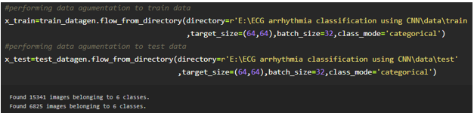

We can see that for training there are 15341 images belonging to 6 classes and for testing there are 6825 images belonging to 6 classes.

Arguments:

directory: Directory where the data is located. If labels is "inferred", it should contain subdirectories, each containing images for a class. Otherwise, the directory structure is ignored.

batch_size: Size of the batches of data. Default: 32.

target_size: Size to resize images to after they are read from disk.

class_mode:

‘int': means that the labels are encoded as integers (e.g. for sparse_categorical_crossentropy loss).

'categorical' means that the labels are encoded as a categorical vector (e.g. for categorical_crossentropy loss).

'binary' means that the labels (there can be only 2) are encoded as float32 scalars with values 0 or 1 (e.g. for binary_crossentropy).

None (no labels).